

**Group 3**

**October 2017**



**USER MANUAL**

Table of Contents

**Group and Project Details** 3

List of participating group members 3

List of dismissed members 3

Major Unresolved Problems 3

List of developed features 4

**Minimum system requirements** 5

OS Requirement 5

Data transmission 5

Message display 5

Message encryption 5

Emailing 5

communication through a network proxy 5

Calender 6

**Additional features** 7

Webmail to store calender 7

Aesthetic and user-friendly UI 7

Tray Notification 7

System Functions 7

**User manual** 8

Primary app 8

Login page 8

Signup 9

Dashboard 10

Sending and receiving messages 11

Emails 12

Calender 12

Changing the proxy settings 13

List of Figures

Figure 1: Login 8

Figure 2: Signup 9

Figure 3: Dashboard/main menu 10

Figure 4: Chat Form (GothamChat) 11

Figure 5: Emails 12

**Group and Project Details**

## List of participating group members

The following members participated in completing the project and it is the opinion of the members of this group that they all deserve to be included as equal contribution members:

|  |  |  |
| --- | --- | --- |
| Role | Name | Student number |
| Usermanual and helping with bugs | Chantel Damon | 24972045 |
| Web based UI and calender | Drikus |  |
| Email en file sending | Wikus Keuler |  |
| Sending of files | Linus Ungerer | 25040162 |
| Background Notifications and System function | Divan Botes | 24244856 |
| Mobile app | Armand Havenga |  |
| Mobile app | Muller Van As |  |
| Mobile app | Thys Van Zyl |  |
| Mobile app and email | Martiens |  |
| Group Leader( setting up TCP/IP and helping other with features) | Werner Alberts |  |
| Helping with setup of TCP/IP protocol and mobile app | Gideon van der Merwe |  |

## List of dismissed members

The following members could not be bothered to participate and were expelled from the group:

|  |  |  |
| --- | --- | --- |
| Role | Name | Student number |
| ? | Moritz Bezuidenhout |  |

## Major Unresolved Problems

The group experienced the following unresolvable problems:

* Members did not show up for meetings and, considering the problematic members in question, they could not be expelled as that would have severely impacted the group’s ability to complete the project;
* Communication on the group chat, people not responding to messages and not participating in important decisions that had to made.

## List of developed features

The following is a complete list of additional features included in the demonstration version of the system. As the minimum requirements are implied and included, this list is limited to the additional features developed.

* Application UIs were developed with a professional design in mind [10];
* Background tray notifications [5];
* System Functions Restart, Shutdown, Wake, Timed Wake, Timed Restart, Time Shutdown[5];
* Text messages sent by the primary app received within 10 seconds [5];
* The primary app supports concurrent and group conversations [5]
* Calender Stores data to webmail

As the weight contribution of these features equal [40], the total number of features comply with the minimum required extra development.

# **Minimum system requirements**

In this section the minimum requirements for the system will be discussed. The discussion will follow the order as they are mentioned in the project description document, namely: OS requirement, data transmission, message display, message encryption, emailing, user friendliness, and communication through a network proxy.

## OS Requirement

The primary application is required to function on Microsoft Windows 7 and later. In order to simplify the development of a Windows based system, the system was developed using Visual Studio 2013 and was coded using the C# language. This combination ensured the application that would run on all versions of Windows that had the required version of the .Net Framework installed. In this instance, the minimum required version was .Net Framework version 4.5.1.

The group experienced no real problems in using this IDE and language. Furthermore, because of the availability of example code on web-based sources such as StackOverflow, a number of the features could be developed using code adapted from these sources.

## Data transmission

## Message display

This application uses a text box to display the message received, the messages will appear underneath each other as they come through, the input message is also done in a text box that can auto scroll as you type your message. We used the usernames to determine the name that should display in chat, your message will display as “You said:……” see Figure 4 for example of display. We used a database to store the usernames and info of the user to be used in chat to display the name and to be used by the email option but that will be discussed later.

The group experienced a number of difficulties in developing this feature. They are:

* Getting name from the database to use in the display.

## Message encryption

## Emailing

Using smtp

## communication through a network proxy

## Calender

# **Additional features**

In this section the additional features that were developed will be discussed. As mentioned in above text these are the extra functions we include in our program explained.

## Webmail to store calender

See the calender discussed above in requirements.

## Aesthetic and user-friendly UI

In order to ensure an aesthetic and professional UI, the following design principles were applied during every phase of the UI’s development:

* Using black background and white text as it is easier on the eyes.
* Using a Dashboard as main menu making all the features easy to find and access.
* User manual can also be easily accessed through the dashboard.
* Making use of simple yet aesthetically pleasing user graphics.

## Tray Notification

The tray notifications pop up whenever data is received by the chat app. It only makes a tray notification when the chat app is minimized. This is done by adding notifyIcon1.ShowBalloonTip(1000, "Bat Signal Activated", "You Have New Messages", ToolTipIcon.Info); to the GChat_DataReceived method in all its if and else methods so that a tray notification is made any time data is received while the chat app is minimized.

## System Functions

System functions include Shutting Down, Restarting, and Waking the pc. These three functions where written into a menu strip on the top of the main screen. The shut down and restart methods are coded very similarly. To cause the pc to shut down Process.Start("shutdown", "/s /t 10"); was used where /s is for shut down and /t 10 to shut down after 10 seconds. For the restart function Process.Start("shutdown", "/r /t 10"); was used where the only change is the /r which is used to restart te pc after the allocated number of seconds after /t. To wake the pc after a certain amount of time is much more complicated. A new class needed to be created with the name wakeUP to accommodate all the methods needed to automatically wake the pc after an allocated time. In this class DLL imports and safeWaitHandles are used to create and set a WaitableTimer from which the program can base its delay which is used to determine how long it must wait before waking the pc from sleep or hibernation. An object of the class is created in the wayneINC class where it is used to link the action of sleeping the pc and starting the timer to wake it with a button. The pc is put to sleep by using the Application.SetSuspendState(PowerState.Suspend, false, false); command.

# **User manual**

In this section the basic functioning of both the primary app and Android apps will be discussed. This will be done in the style of a user manual, n screenshot with a short description will be given

## Primary app

### Login page

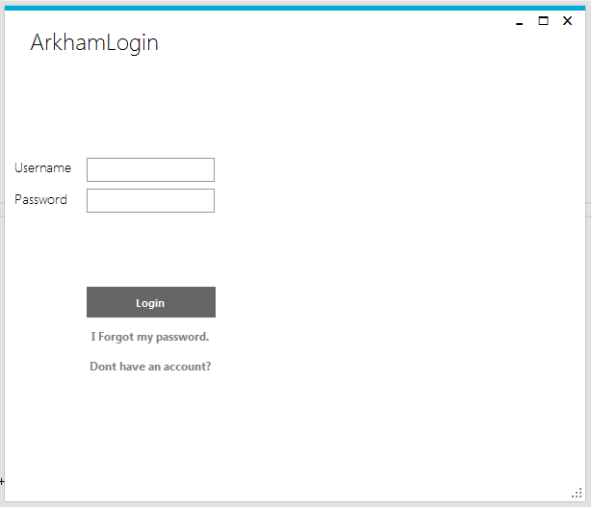

Figure 1: Login

This is the login in page the first part of the app you see when you start it. If you are a first time user please click on the Don’t have an account link, we will discuss how that works below (figure 2) as for the login after you have created your account enter your username and password in the corresponding textboxes and then proceed by clicking o0n the login button.

### Signup

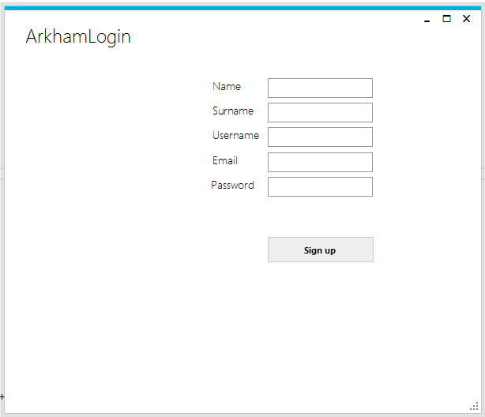

Figure 2: Signup

If you clicked on the “don’t have an account” the login in screen will now look like this, please input the required data in the corresponding blank spaces and click the signup button you can now use the username and password you choose here to login into the app.

### Dashboard

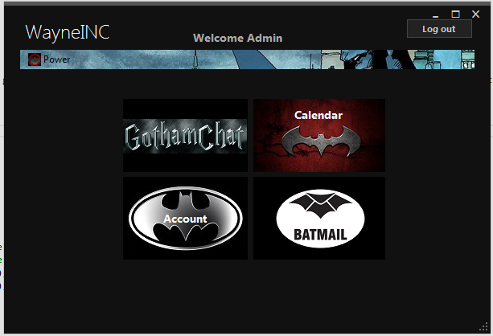

Figure 3: Dashboard/main menu

This is the screen opens after you successfully logged in on the previous from here you can see all the functions of your app. The power button on the top controls all the power functions, like to restart the computer(now or after a set time), shut down the computer or to turn in on after is has been slept. Gotham chat opens the chat function, where messages can be sent and received as well as files. Calendar opens functions to schedule appointments and send email to make appointments with others. Batmail is your email function where you can send and receive emails from the email account of your choice.

### Sending and receiving messages

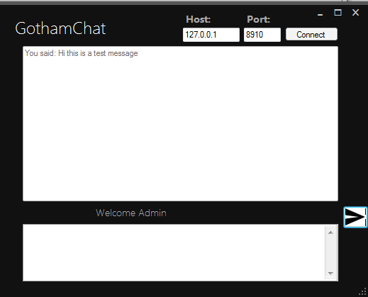

Figure 4: Chat Form (GothamChat)

Click the connect button first in the white block (textbox) enter the message you would like to send and click on arrow shaped button to send the message you typed. Message will display in the bigger block above like in the image. To see instruction on change proxy settings click here.

### Emails

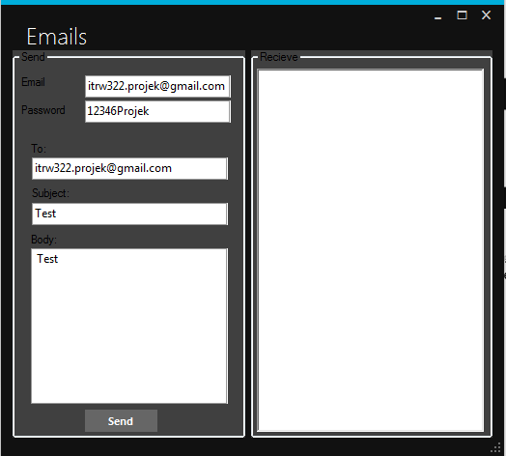

Figure 5: Emails

Enter you email and password in the top two boxes (password is masked when viewed this is just to help with the explanation that you can see what the password is). Next you can fill in the text boxes as you would a normal email. The emails you receive on this account will be view in the large white block.

### Calender

### Changing the proxy settings

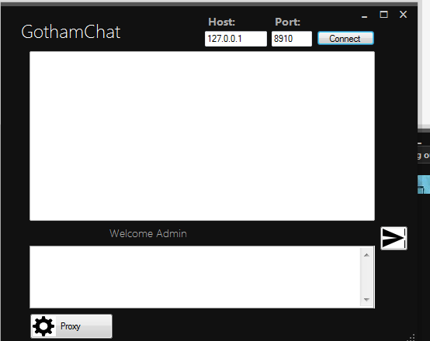

Figure 6: Chat app before clicking proxy button

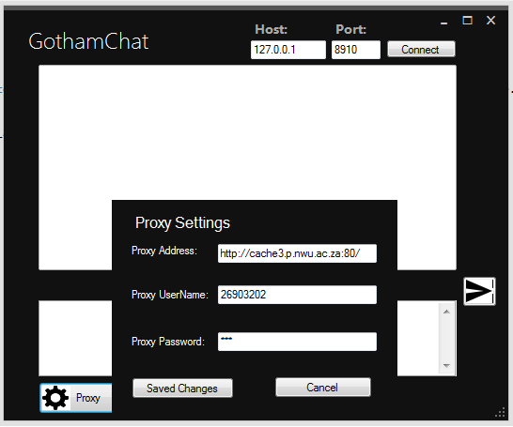

Figure 7:Chat from after Clicking proxy button

In the chat part of the app you can change the proxy settings by clicking on the proxy button, this will open a panel of setting you can fill in to change your proxy settings. The default proxy is already in the text box after you are done changing the proxy you click save changes.